**Student Name: Shinde Smita Shahaji**

**UID: 20BCS4643**

**Date of Performance:3/4/2021**

**Branch: CSE-IOT Section/Group: B**

**Subject Name: Digital electronics lab**

**AIM**

Design a logical gate based system that activates a security alarm when both the lights available in a house are turned off.

**Hint: Use NOR gate.**

Design a logical gate based system that activates a security alarm when both the doors of a showroom are locked

**Hint: Use NAND gate.**

Design a logical gate based system that activates a camera available at entry of house when someone presses the doorbell or when someone stands on foot mat near gate. Ensure that if someone presses the doorbell while standing over the foot mat, the doorbell does not ring.

**Hint: Use XOR gate.**

**Task to be done**

1. Two-way switch for room light using XOR gate
2. **LED flasher using NAND gate.**
3. **Multiplayer game trigger using NOR gate**

**Design daily life equipment using XOR,NOR & NAND gate.**

**Requirements**

# Software -

Tinker cad.

# Hardware –

1. 7400 (NAND) IC,
2. 7402 (NOR) IC,
3. 7486 (XOR) IC,
4. 5V Power Supply,
5. Breadboard,
6. Connecting wires,
7. Simulation software,

**Circuit diagram/ Block diagram**

**Two -way switch-**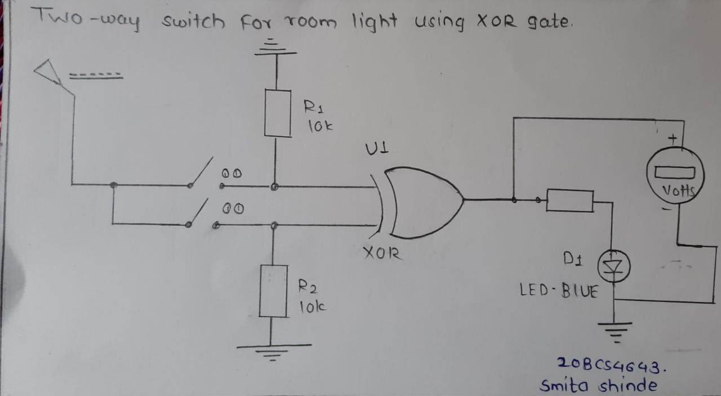

**LED flasher**

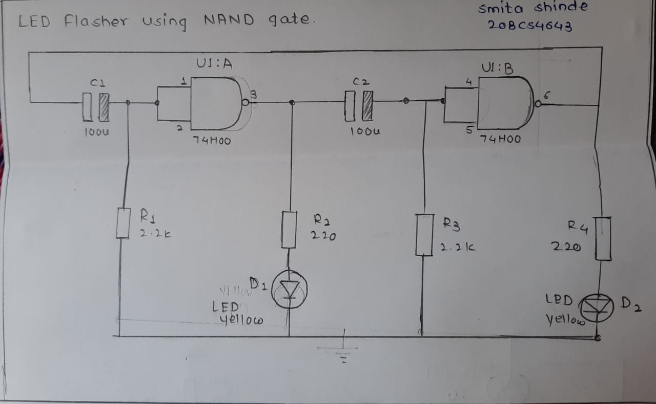

**Game trigger-**

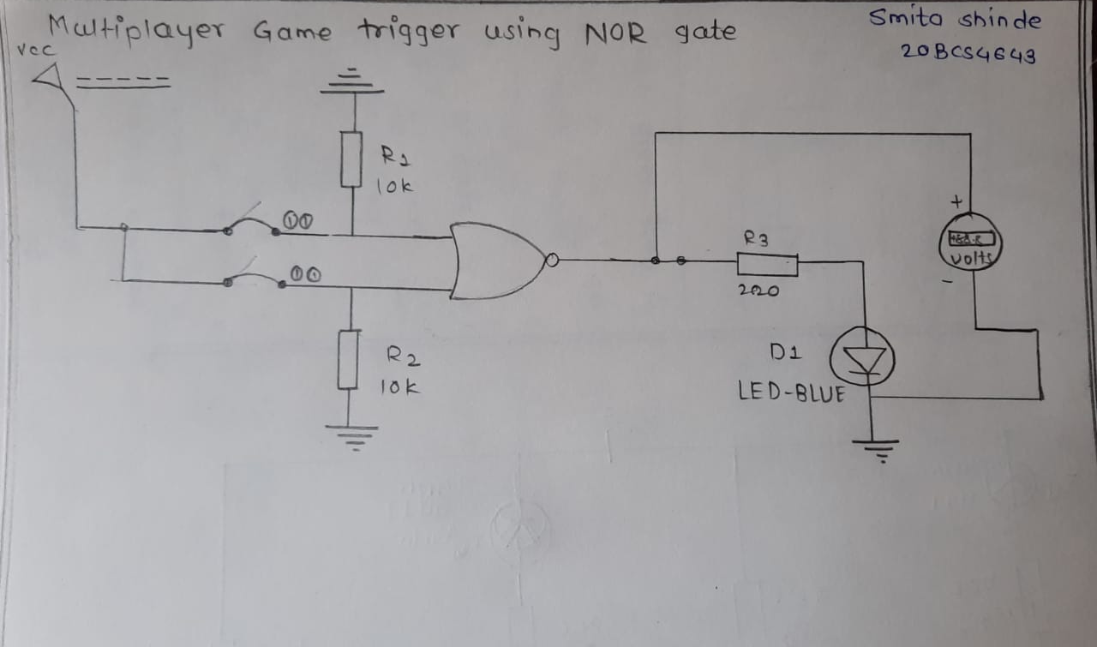

**Simulation Results:**

1. Two-way switch for room light using XOR gate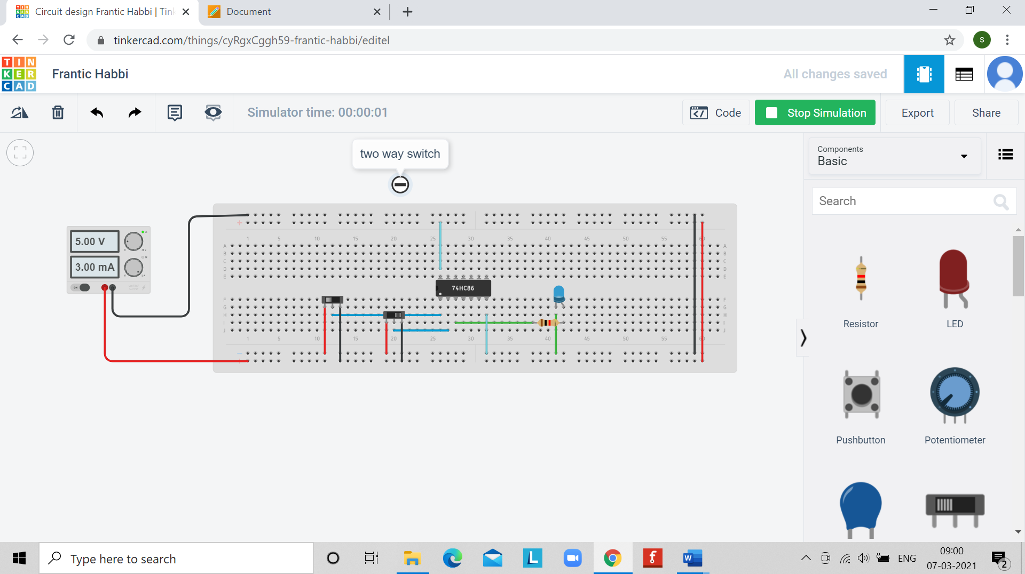2.**LED flasher using NAND gate**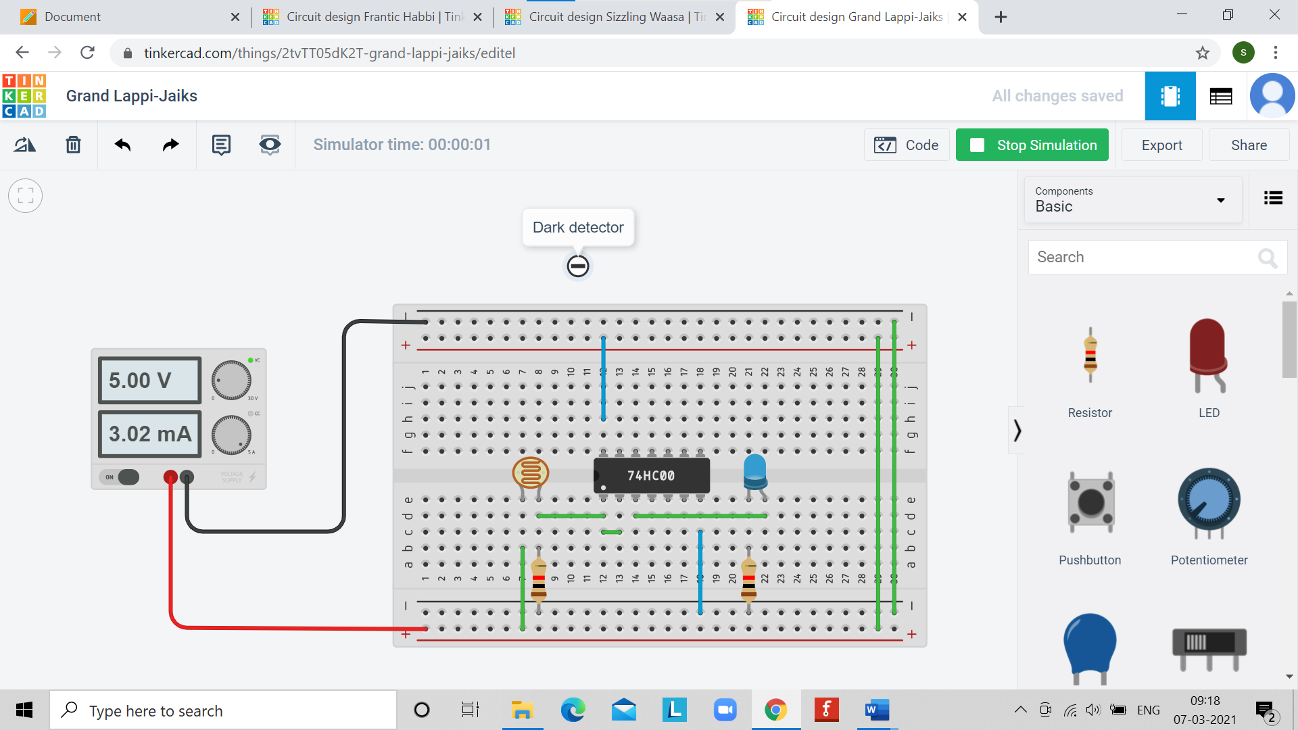

**3.Multiplayer game trigger using NOR gate**

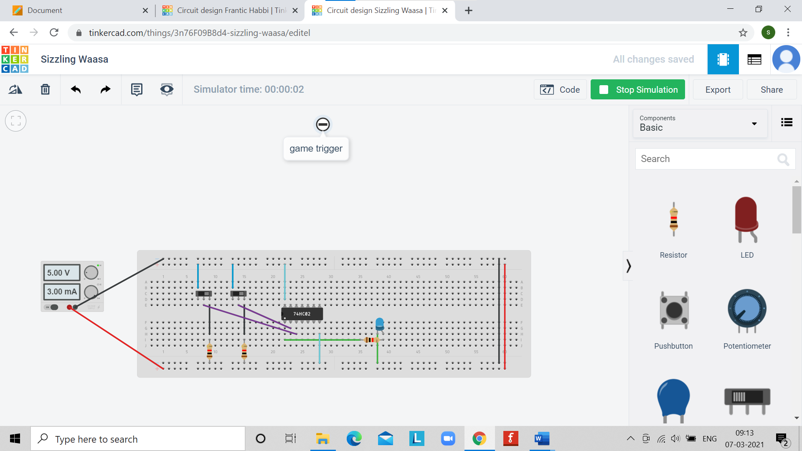

**Concept used**

# Two-way switch-

1. A two-way light switch turns on the light to be switched from any station.

1. This means that at any time, either switch may be upside-down so that it's on in the down position or off in the up position.
2. The lighting circuits that save time, like the light switch in the kitchen that switches the light in the garage off, and the same circuit can be switched off at the front end of the garage, saving you having to return to the kitchen.

|  |  |  |
| --- | --- | --- |
| Input A | Input B | Output C |
| 0 | 0 | 0 |
| 0 | 1 | 1 |
| 1 | 0 | 1 |
| 1 | 1 | 0 |

1. Another application would be the light on the stairway on different floors, saving you from having to go up or downstairs to get the switch.

# Dark detector / LED flasher-

1. The inputs of the NAND gate are joined, therefore when the input is logic 1, the output is logic 0, and when the input is logic 0, the output is logic 1, hence it behaves as a NOT gate. NOT gates could also be used making it a “NOT Gate LED Flasher".
2. The capacitor receives charge then the output from the previous gate goes high, which means that the following gate gets logic 1 input when the capacitor has sufficient charge.
3. When light fall on the LED is not glowing s inversely proportional to light when intensity of light is high output is low and vice versa.

# Game trigger-

1. The Logic NOR Gate is a combination of the digital logic OR gate and an inverter or NOT gate connected together in series.
2. he inclusive NOR (Not-OR) gate has an output that is normally at logic level “1” and only goes “LOW” to a logic level “0” when ANY of its inputs are at logic level “1”.
3. The Logic NOR Gate is the reverse or “Complementary” form of the inclusive OR gate. The NOR gate can also be classed as a “Universal” type gate. NOR gates can be used to produce any other type of logic gate function just like the NAND gate and by connecting them together in various combinations the three basic gate types of AND, OR, and NOT function can be formed using only NOR gates.
4. In order to implement the multiplayer game trigger mechanism, it required to initiate the game when the detection of both the players competing in the game as present at the designated completing stations.

**Learning/ observation-**

1. Basic application of NAND, **XOR & NOR gate in day-to-day life equipment’s/applications.**
2. **Based upon their truth table and input output pins.**

**Troubleshooting**

1. Connections are not connected properly Should be all connection will be connected.
2. For NAND gate pin no.1 & 2 are inputs and pin number 3 is output by mistake connections are connected wrongly and NAND get crashed. and Most careful about input and output connections.

##### ****Result-****

The practical applications of logic gates (NAND, NOR & XOR) were studied and implemented.